Create a windows Vm machine in AWS and connect with RDP open CMD in windows share the about system info

1. Create a Windows VM in AWS console

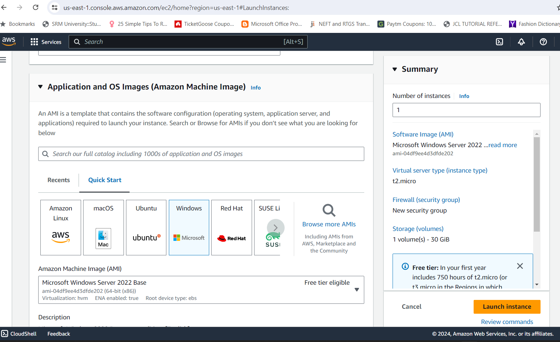

1. Enable port 3389 RDP in the security group of the EC2 instance.

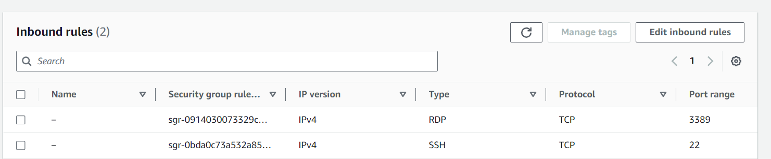

1. Connect to your instance via RDP client as shown below

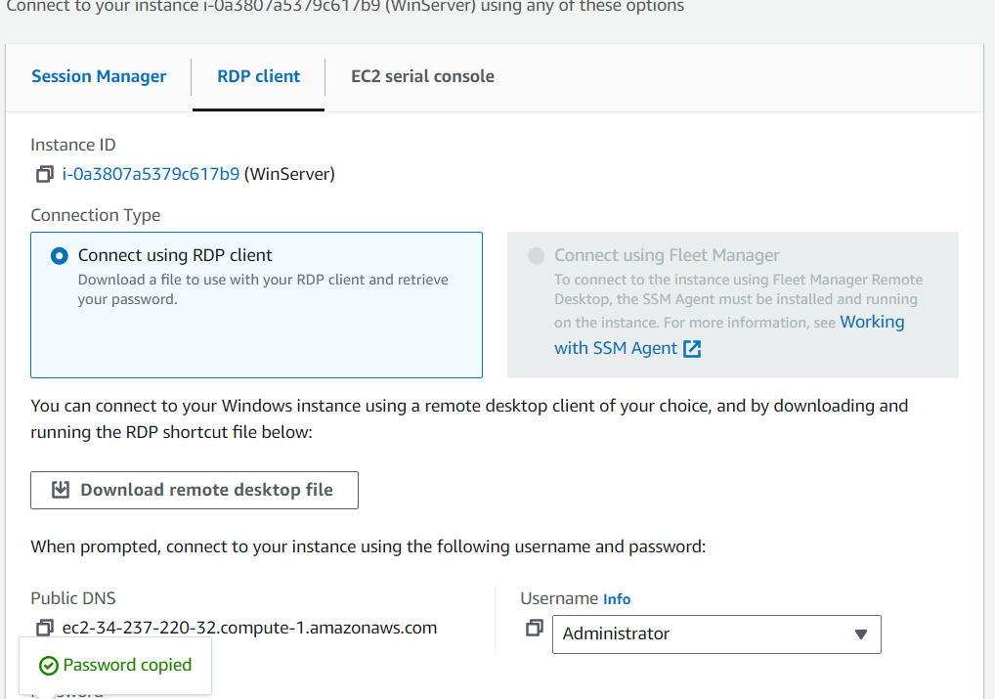

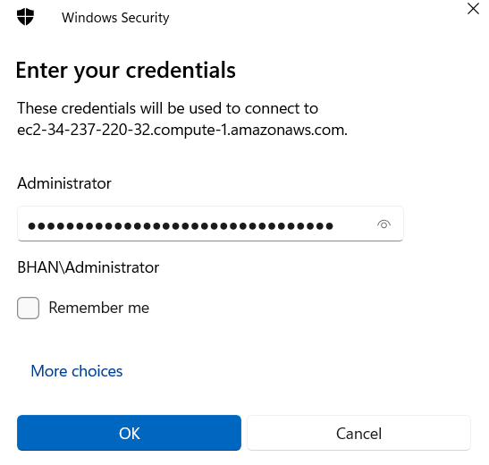

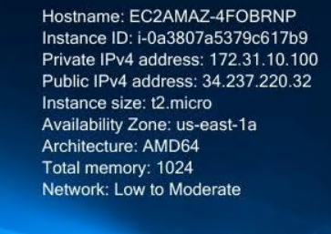

1. Type the **systeminfo** command in the cmd this will display the about system info.

